# Assignment M4

## Introduction

The project that my group and I will be working on is Redesigning ATMs (Automatic Teller Machines). I assumed that a user is purchasing goods at some sort of physical marketplace and doesn’t have a form of payment available. For my prototypes, I had selected verbal, paper, and textual prototypes that respectively link to a phone app, having the user enter their own information into the ATM, and a key fob loaded with the user’s account information. More information can be found in my Appendix.

# Appendix

## Assignment M3

The project that my group and I will be working on is Redesigning ATMs (Automatic Teller Machines). I assumed that a user is purchasing goods at some sort of physical marketplace and doesn’t have a form of payment available. For my brainstorming plan, I want to come up with ideas to design a way for a user to access their account through an ATM without having a debit card. While brainstorming, I need to keep in mind the standards in security that ATM’s already have in place and not interfere with those. I hope to have the brainstorming done within a couple hours. The only rule here would be that the user does not have their debit card available. Otherwise, the ideas should be free form. In some cases, the ideas can be divulged from other ideas.

Now that I have completed brainstorming, I have come up with a couple ideas. The first idea would be to have the user enter in their bank’s routing number as well as their account number and pin to their debit card. This is additional steps, though, and also forces the user to remember that personal information. Another idea is using fingerprint scanners or other biometric scanners on the ATM, but this represents a definite cost increase as well as additional security implementations in ATM’s. My final idea would be a key fob on your keychain that allows you to access the ATM the same as your debit card would while still requiring your pin number and other information. A fourth, and final idea, would be to allow someone to use their phone to access the ATM. This idea already seems to be in place, but isn’t implemented in most places.

For my selection criteria, I need to make sure that the security of the ATM remains intact. I also want to make the process as easy as the current the process when accessing your account information at an ATM. Building on that, the familiarity and consistency of the interface shouldn’t change much, just the ways the process begins. This is such things as timeliness, typical UI layouts, and more. I don’t want the user to have to fumble around when trying to withdrawal money. So for these reasons, I have selected the key fob, the phone app, and the process of entering in the routing and account numbers.

For the phone app idea, I will try to use a verbal prototype. Many people already have apps on their phone to access their account, transfer money from one account to another, and do many other things that the ATM can be used for. Unfortunately, it cannot be used to actually withdrawal money from an ATM. If an ATM were to use Bluetooth or other Near Field Communications, it could easily connect with any smartphone. The ATM interface wouldn’t change in this instance. It would, instead, just adapt to use the bank’s app that they already have. The phone could connect to the ATM, pass over the user’s account information, and the next step would require the user to enter in their PIN (personal identification number) into the ATM. The user would continue to get through the standard process of getting money out, while skipping the process of having to provide their debit card. This also addresses the issue in my data inventory of skimming devices. Skimming devices won’t be helpful to the unlawful as no debit card will be used. The design is fairly easy to use for most users and only requires a smart phone with the app of the bank that the user is a customer of.

For the idea of having the user enter in their own information, I have created some paper prototypes. It is my idea that the user would first be asked if they want to use their debit card or if they want to manually enter in their bank’s information. If they choose manual, they will be required to enter in their bank’s routing number as well as their account number and PIN. After they have entered in their PIN, the screens would continue on in the same fashion that ATM users are accustomed to. If they were to choose debit card, they would skip entering this information in. Again, if they choose to manually enter in their information, this handles the issue in my data inventory of not needed to worry about getting your card skimmed. Where it does lack security is with the keypad. If a keypad overlay is used to gather information for unlawful use, then the unlawful person has much of the user’s personal information. Security, though, isn’t effected much by this design as we already deal with these issues in real life. You will find my paper prototype drawings at the end of this paper.

For my third idea of the key fob, I will use a textual prototype. For background, the ATM will need to implement Near Field Communications much like in first prototype of using a phone app to access your ATM. The key fob will have the user’s bank data registered and the ATM will be able to read that using a low strength Bluetooth or other NFC. In this instance, the user can either use the key fob given to them by the bank or use the debit card that was given to them by their bank. This also alleviates the card skimming issue in my data inventory, as well as not having their debit card. It does not decrease the security in anyway.

* Scenario: the user is at an ATM that allows key fob access. The user has a need to access their account, withdrawal money, and/or perform other functions. The user does not have their debit card or phone, nor do they remember their account number. They do have a key fob that has been given to them by their bank.
* User walks up to ATM
* User selects “use key fob” function rather than inserting debit card.
* User places key fob on the ATM.
* ATM asks the user for their PIN
* User is able to withdrawal money, check balance, and any functionality that is offered when a user uses their debit card.
* User ends the transaction however they typically would at that specific ATM.

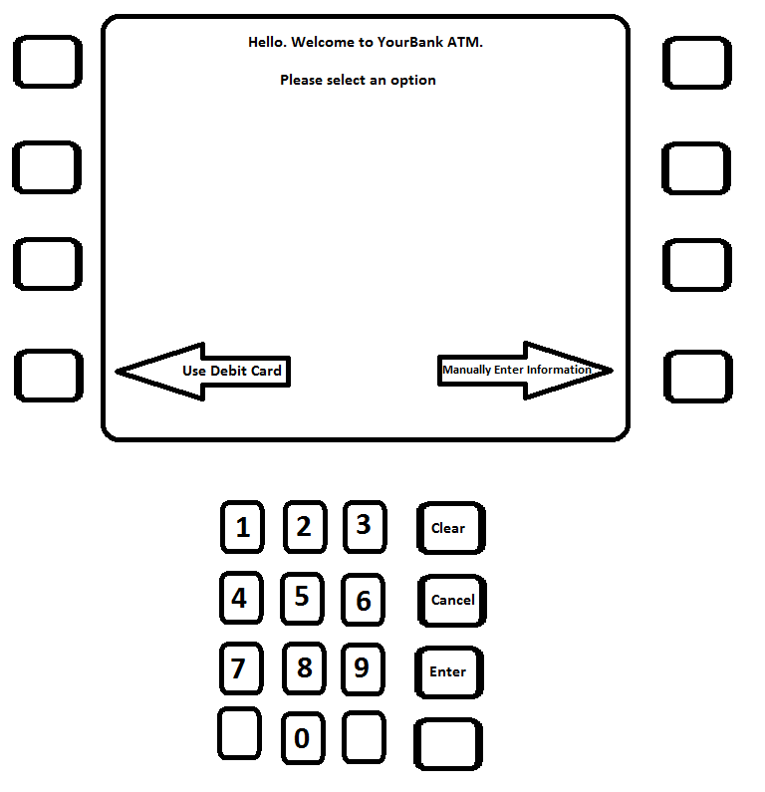

**Screen 1: Choose Manually Enter or Use Debit Card**

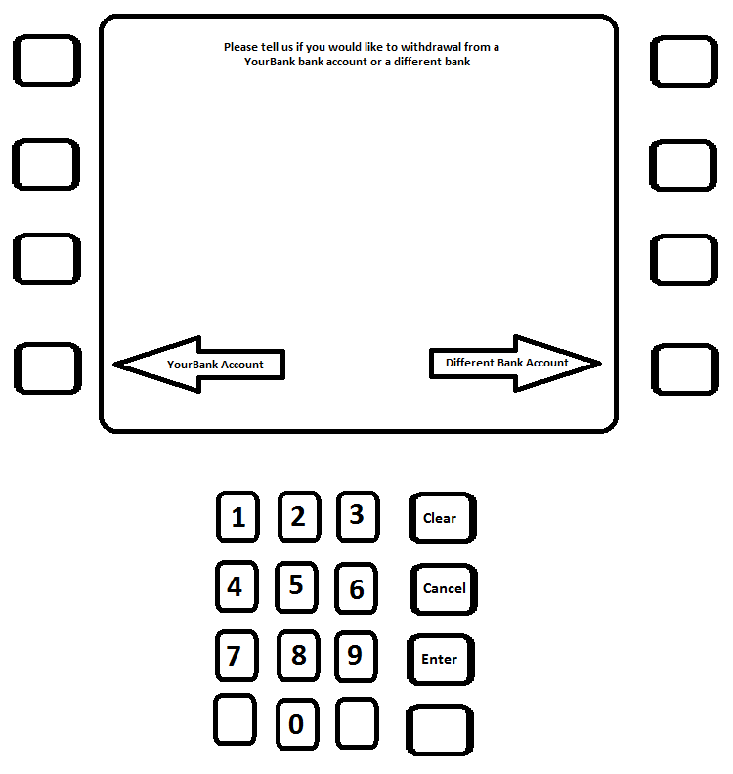

**Screen 2: Choose the current bank’s routing number or enter in a different bank’s routing number**

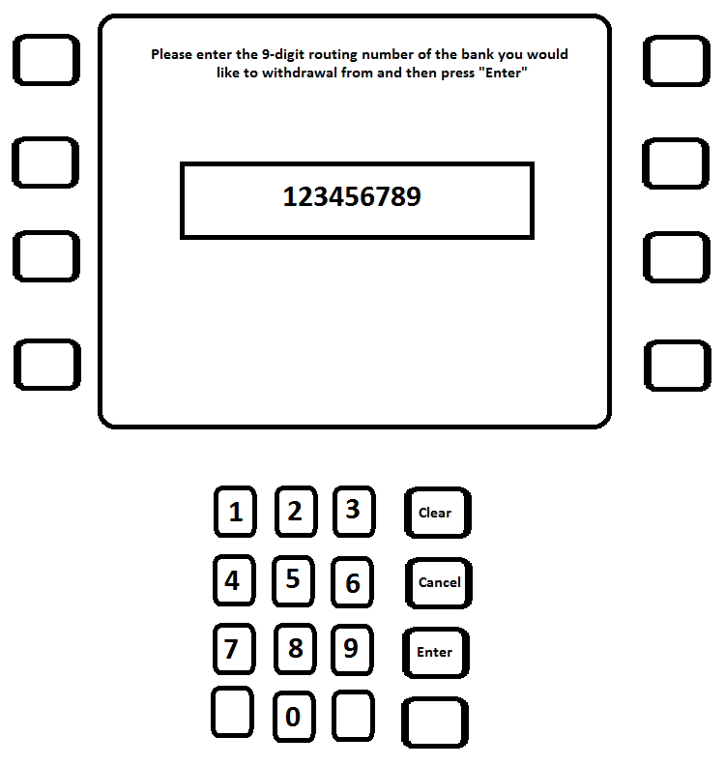

**Enter Routing Number Screen**

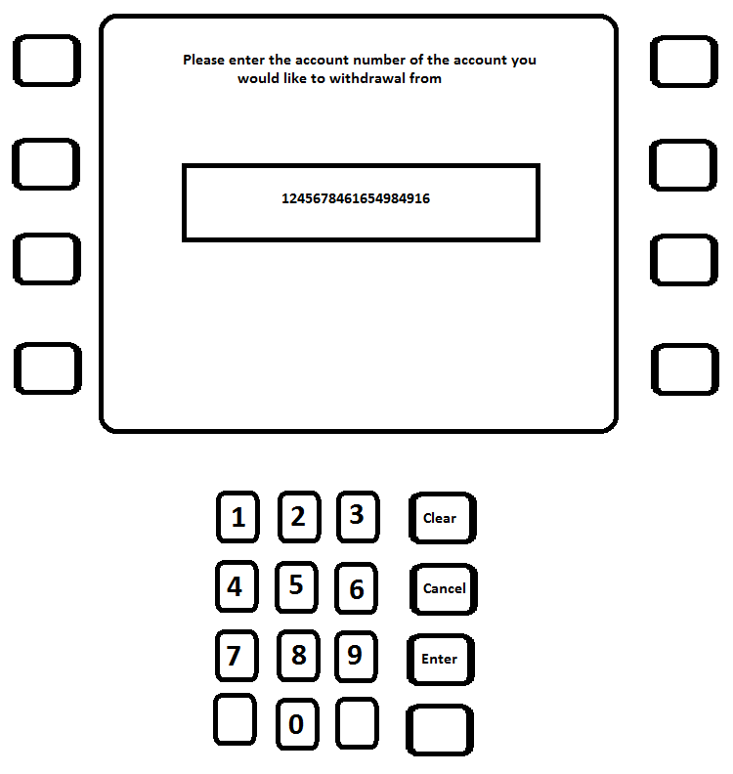

**Enter Account Number Screen**

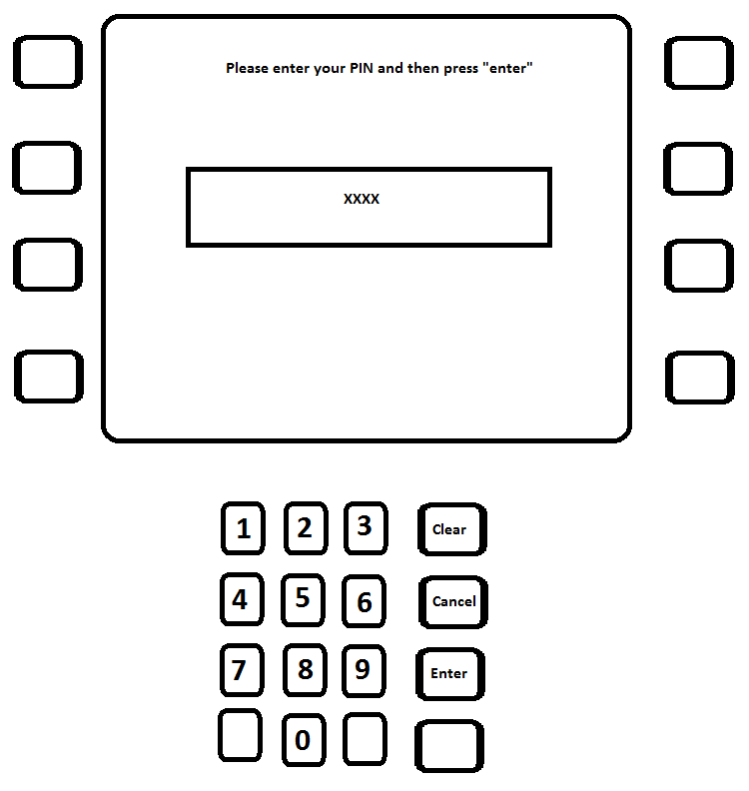

**Enter PIN Screen**

# Assignment M4 Instructions

Due: Sunday, November 6th, 2016, by 11:59PM [UTC-12 (Anywhere on Earth)](https://www.timeanddate.com/time/zones/aoe). This assignment is based on lesson 3.6 (Evaluation), and focuses on laying out your evaluation plan.

## Assignment Instructions

Answer the following prompt in a maximum of 1200 words, with a recommended length of 1000 words; if you supply more than 1200 words, the grader will stop reading at the 1200th word, and you will not receive credit for anything written after that. You are encouraged but not required to complement your responses with diagrams, drawings, pictures, etc.; these do not count against the word limit, though any captions, text in tables, etc. does.

Select three types of evaluation to perform: one qualitative, one empirical, and one predictive. For this assignment, each evaluation should target a different prototype from your previous assignment; evaluate one qualitatively, one empirically, and one predictively.

For the qualitative evaluation, select one of the methods for qualitative evaluation, like interviews, surveys, think-aloud protocols, focus groups, or post-event protocols. First, layout the evaluation plan, including who the participants will be, where the evaluation will take place, and whether/how it will be recorded (~150 words). Note that unless you have IRB approval for your evaluation, your evaluation should take place with friends, family, or classmates. Then, lay out the actual content of the evaluation, such as the interview questions that will be asked, the survey questions that will be administered, or the post-event protocols that will be followed (~100 words). For example, for a  live Wizard of Oz prototype, you might script a session that demonstrates each aspect of the interface, then perform a post-event protocol to get the user’s thoughts. For an asynchronous paper prototype, you might send the prototype to participants with questions to answer in text. Finally, discuss how the evaluation will address the requirements in the data inventory and/or requirements definition phases (~100 words).

For the empirical evaluation, first define your control and experimental conditions. What are you testing, and what are you using as a point of comparison (~100 words)? Then, define your null and alternative hypotheses; remember, the null hypothesis is what you assume to be true unless you can find conclusive proof for your alternative hypothesis (~50 words). Then, describe the experimental method you will use. How will subjects be assigned to groups, what will they complete as part of their condition, and what data will they generate (~100 words)? Finally, identify what lurking variables might confound your data (~50 words) and describe how you will analyze your data (~50 words).

Note that given the early stage of your project, empirical evaluation may be tough to design. In the next assignment, you will select two of these three evaluations to actually conduct, so you may design your empirical evaluation in a way that would be unfeasible to carry out based either on the available resources or the status of the prototypes. The important task here is to experience planning the three types of evaluation.

Note that in planning either the qualitative or empirical evaluation, you *may* use the peer review exercise on this assignment as your data-gathering method by having your peer reviews complete the evaluation exercise and respond to a survey. If you choose to do this, the evaluation for your peer to complete should be the first thing they see upon opening the assignment, and should provide very explicit instructions for how to evaluate the interface, such as the interfaces to look at, the questions to answer, and where to supply the responses.For the predictive evaluation, perform either a cognitive walkthrough of your prototype or construct one or more GOMS models of the user’s interaction with your prototype. If you conduct a cognitive walkthrough, layout in hierarchical detail the goals, perception, reasoning, and actions of the user at every stage of interaction with the prototype. A cognitive walkthrough may be presented in text (~250 words or equivalent detail). If you complete one or more GOMS models, lay out the goal, initial status, methods, operators, and selection rules in sufficient detail; you may use text to further explain the GOMS model(s). Note that in either of these cases, completing the walkthrough or the model is *not* the evaluation exercise; this merely provides the model that can be evaluated in the next assignment.Finally, select which two of these evaluation approaches you will complete for the next assignment (~50 words), and explain why. It is acceptable for the ‘why’ to be superficial reasons, e.g. “My prototype isn’t ready for empirical evaluation” or “I can’t recruit people to participate in my qualitative evaluation”.